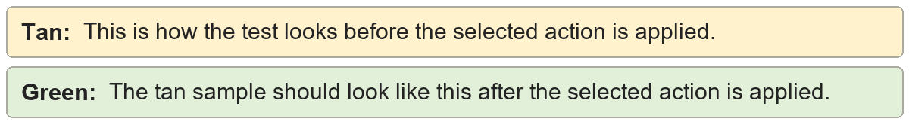
Sentence boundaries | the first sentence starts low. the second sentence starts low.
Sentence boundaries | The first sentence starts low. The second sentence starts low.

Abbreviations | dr. smith met mr. jones before noon.
Abbreviations | Dr. smith met Mr. jones before noon.

Acronyms | the nasa api exports pdf reports for vba users.
Acronyms | The NASA API exports PDF reports for VBA users.

Names and brands | cleanupsuite works with github and chatgpt.
Names and brands | CleanupSuite works with GitHub and ChatGPT.

Heading context | a pasted heading for the document

Heading context | A Pasted Heading for the Document

